**University Report**

**Team: Illegal Skills Exception**

**Sumesh Harale – 001069129**

**Krishna Tejnarayan Singh – 001028148**

**Santhosh Krishnan - 001029708**

**Problem Statement**:

Create a performance measurement solution to enable universities to measure the quality of the education they deliver to their students. The approach will be to look into how an educational system in terms of faculty and courses contribute to the growth of their graduates over a 5-year period. Figure out ways to track the jobs and promotions graduates get over time and assign rankings accordingly. In addition, track the connection of courses and their relevance to graduates growth. One of the deliverables will be to design a dashboard that enables college and university administrators to compare the performance of their academic units.

**Abstract**:

To develop an application where student alumni can enter their job relevant details for past years.

This information will be used by university admin to create a performance review system where he will be able to figure out which courses and which professors are most relevant as per the current job trend.

**Modules:**

This Java project consists of 2 major modules

#### **Admin:**

* Admin Login with Username & Password
* View student’s employment history and feedback
* View dashboards with courses, university and department ranking
* Logout

#### **Student:**

* Register
* Enter employment history
* Enter relevant course professor feedback
* Logout

**Design Approach**:

**Student login**:

Student signup into the university portal with their relevant details.

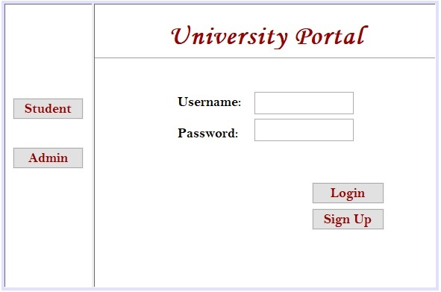

After signing up, the student logs in to the portal and is taken to Employment History page to insert their relevant job details.

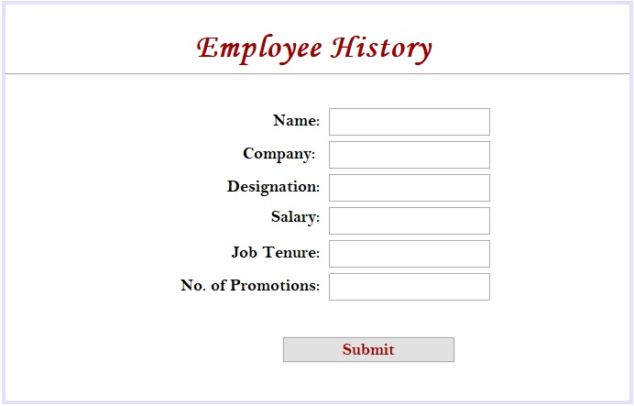

After the student has entered the job details, he will be navigated to the Feedback page where he answers few questions.

Student will be prompted to select his department.

After selecting the department, student will be asked whether the courses he took in university helped him to get his current job or not.

If student selects No, then a method will be called to increase the number of students whose Degree didn’t have any impact for him in landing a job.

If student selects Yes, then he will be routed to below Feedback page.

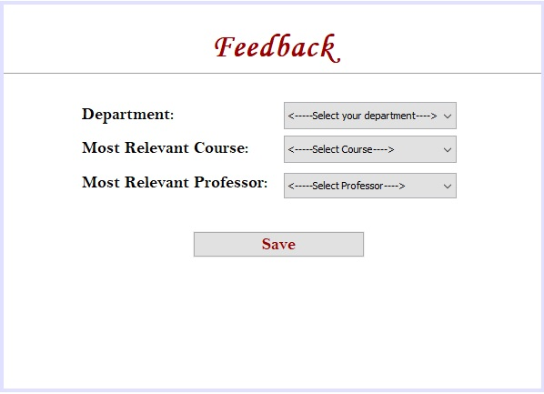

After entering the feedback into the application, student logs out of the application.

**Admin Login**:

Admin logs into the system using admin login credentials.



Once the admin is logged in the system, he will be prompted to the screen where he will find all the relevant tabs of University Model – like Department, Faculty Directory and so on.

Along with all the university model tabs, admin will be able to see 2 more new tabs:

* **Student Employment History**
* **Rankings**.

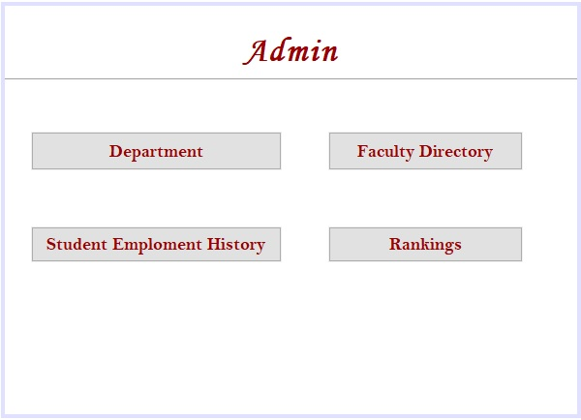

If the admin selects the Student Employment History tab, he will be able to see the summary of total number of students who logged into the application.

He will be able to view total number of students who took the survey.

The second field displays the count of students who think their degree was relevant for them in order to get their job.

The third field displays the count of students who think their degree was irrelevant for them in order to land them a job.

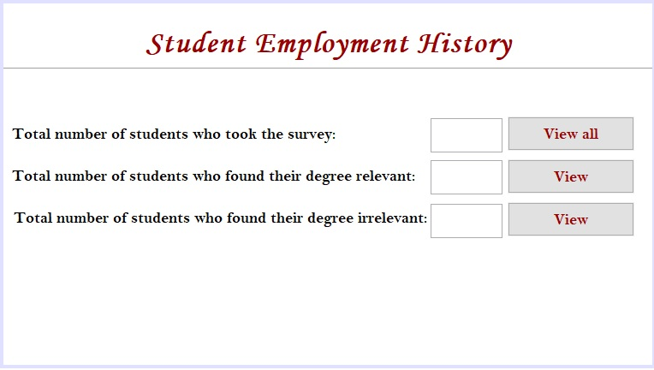

If admin clicks View All button, he will be able to view the list of students who took the Employment History survey.

Similarly, if he clicks chooses View, then list of students who found their degree relevant for getting a job and the list of students who found their degree irrelevant for getting a job will be displayed respectively.

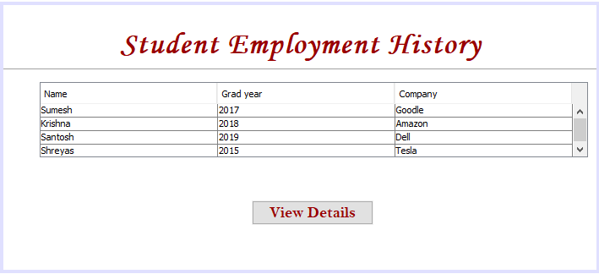

From the above list of students, admin can select any student and view their full details.

He will also be able to update any field entered by the students – this feature will enable the admin to rectify any wrong information entered by the students.

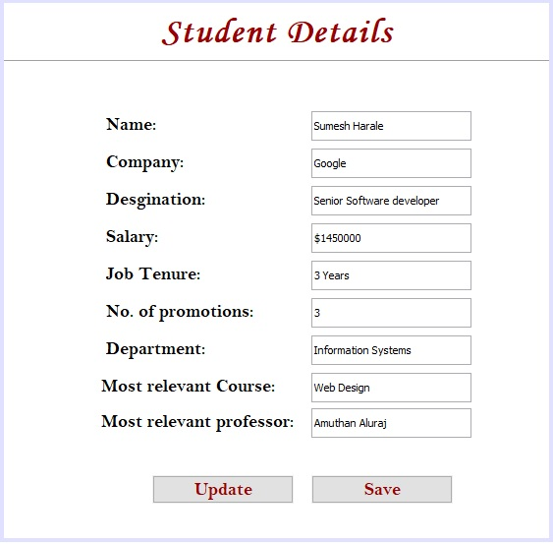

When admin selects the Rankings tab, he will be prompted to dashboard with multiple tabs of rankings to choose from.

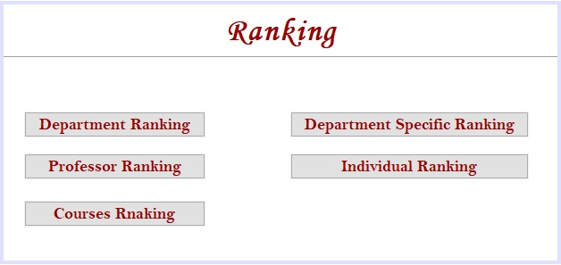

If the admin chooses the Department Ranking tab, the program will look into the ArrayList having department name and the count of number of times that department’s student has provided positive feedback, i.e.; their department’s courses helped that student to secure a job. This list will be displayed, sorted by their ranks.

If the admin chooses the Professor Ranking tab, the program will look into the ArrayList having Professor name and the count of students picked that professor and found whatever he taught in his class relevant for securing job. This list will be displayed, sorted by their ranks.

If the admin chooses the Courses Ranking tab, the program will look into the ArrayList having course name and the count of number of times that particular course has been picked by student as it helped them to secure a job. This list will be displayed, sorted by their ranks.

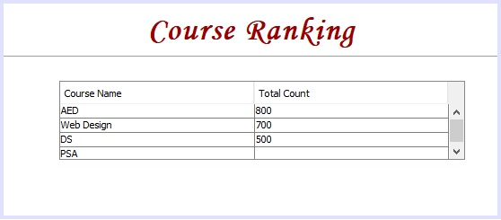

If the admin selects the Department Specific Ranking tab, he can view the rankings of professors and courses specific to a particular department.

Once admin is inside Department Specific Ranking dashboard, he will be asked to select a department.

Once he selects a department, he can view the ranks of professors and ranks of courses within that department.

